Training Course & Seminar of Marine geological resources
Introduction
Marine geological resources of energy, minerals vital to emerging communication, and information technologies and raw materials for construction arouses the worldwide interest. Resources of high interest and value are gas hydrates, deposits of rare earth elements, polymetallic minerals and sand and gravel deposits for construction and beach nourishment.
The training course and seminar will mainly focus on gas hydrates and metallic minerals. Gas hydrates form at elevated pressure and low temperature conditions and if sufficient amounts of gas and water are available. There are more than 500 hydrothermal vent sites all over the world which represent some of the last untapped deposits of precious metals on Earth. On closer inspection we learn that certain thermodynamic conditions have to be provided for the hydrate formation process. How can we describe the formation process from a thermodynamic point of view? What do we have to consider when we transfer this to lab experiments and the natural environment? How can we explain the varying thermodynamic properties of mixed gas hydrates, their phase behavior and the coexistence of hydrate phases? What affects the hydrate formation and dissociation kinetics? How can we apply this knowledge on the development of safe and efficient production methods?
The training course will provide the fundamental thermodynamics and several application examples. Experimental observations and results will be discussed and interpreted under these aspects. Based on this knowledge we predict the behavior of gas hydrate phases and metallic minerals due to changes in their environment and discuss potential production methods with regards to their efficiency and safety.
Seminar & Course Schedule
October 9 – 12, in Guangzhou Institute of Energy Conversion, Chinese Academy of Science (GIEC-CAS)
Date | Course Content | Instructor
Day 1  (09. 10. Tue) | - Basics: Introduction of the course  - Theory: Formation of hot vent  - Theory: Characterization of hot vent | Dr. Lihua Liu  Dr. Yejian Wang
Day 2  (10.10, Wed) | - Practice: Exploration of hot vent  - Basics: Introduction of gas hydrate  - Theory: Thermodynamic conditions for hydrate formation  - Practice: Application to experiments | Dr. Yejian Wang  Dr. Judith Schicks
Day 3  (11.10, Thu) | - Basis: Hydrate nucleation and growth hypothesis  - Practice: Discussion of experimental observations  - Theory: Thermodynamic properties of gas hydrate and hydrate formation kinetics  - Practice: Thermodynamic versus kinetic - discussion | Dr. Judith Schicks  Dr. Yejian Wang
Day 4  (12.10, Fri) | - Theory: Gas hydrate formation in nature  - Practice: To what extend can we transfer results from the lab to natural condition? –discussion  - Theory: Are THF-hydrate and ice appropriate substitutes for gas hydrates?  - Summary and discussions | Dr. Judith Schicks  Dr. Yejian Wang  Dr. Lihua Liu
Potential audience:
- Post-graduate students and early career researchers working in the field of marine geology.
- Whose main research interest lies on the topic oil, gas and metallic minerals exploration, reservoir simulation, transport and degradation of volatile organic compound in the shallow subsurface etc.
- Who wishes to learn the basic theory behind fundamental thermodynamics, while also wish to have hands-on experience of setting up.
Participants are expected to:
- Bring their own working laptop, as well as an independent mind;
- Not afraid of operating a computer in the command line interface;
Date, Location and Registration
The symposium & course will last for 4 full days, from 9th to 12nd Oct. 2018, and the lectures would be in English and or Chinese.
Interested participants are expected to send their personal information to Yuan Yuan (yuanyuan@ms.giec.ac.cn) and cc Dr. Lihua LIU (liulh@ms.giec.ac.cn) no later than 26th Sep. 2018. Only a limited amount of vacancies are provided for external participants.
No accommodation in the GIEC, further information could contact with the organizer (yuanyuan@ms.giec.ac.cn) in advance.

About the lecturers
Priv. Doz. Dr. Judith Schicks
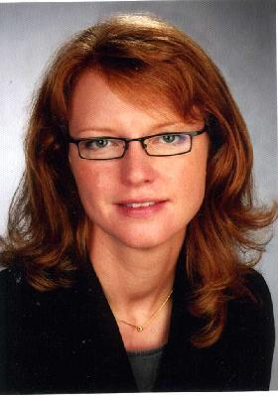
https://www.gfz-potsdam.de/en/staff/judith-schicks/sec31/

Dr. Yejian Wang
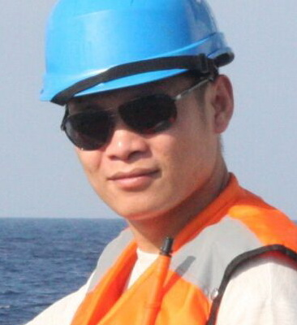
http://www.klsg.org.cn/redir.php?catalog_id=1735&object_id=1805

